PROJECT AGREEMENT
Project Name: BookLoop – Online Book Rental Subscription Platform
Customer: BookLoop
Development Team: Itssme
Team Member: Abduvoxidova Samira (202490023)
Date: October 16, 2026

1. Project Purpose
The purpose of this project is to design an online book rental platform where customers can rent physical books through monthly subscriptions.
BookLoop allows users to order books online, receive home delivery, and return old books when new ones are delivered.

2. Project Scope
The proposed website will include:
- User registration and login.
- Membership plans (Basic, Standard, Premium).
- Book catalog and search.
- Book rental and ordering system.
- Delivery and book return management.
- Admin dashboard for managing books and orders.
Digital e-books and mobile app development are not included.

3. Customer Requirements
The customer requires:
- A simple and user-friendly website.
- Different membership plans with rental limits.
- Online book search and ordering.
- Home delivery with simultaneous book exchange.
- Book availability and rental tracking.

4. Project Deliverables
- Project Plan
- Project Contract / Agreement
- Use Case Diagram and Specifications
- Business Process Model (BPM)
- Work Breakdown Structure (WBS)
- Gantt Chart
- Final Report and PowerPoint Presentation

5. Schedule and Responsibilities
Project Start: September 28, 2026
GitHub Deadline: October 8, 2026
Presentation: October 20, 2026

Customer Responsibilities:
- Define business needs and membership rules.
- Review the proposed system requirements.

Development Team Responsibilities:
Itssme consists of one student, Abduvoxidova Samira, responsible for:
- Project planning and requirements analysis.
- Preparing diagrams and project documentation.
- Creating the final report and presentation.

6. Budget
This is an academic project, so no actual investment is required.
Future costs may include website development, book purchases, delivery services, and maintenance.

7. Changes to the Project
Any major changes to the project scope or requirements will be reviewed and documented before being included in the project.

8. Agreement and Approval
This agreement defines the project scope, responsibilities, and expected deliverables.
As the only member of Itssme, I agree to complete the project according to the course requirements.

Customer: BookLoop
Team Leader: Abduvoxidova Samira
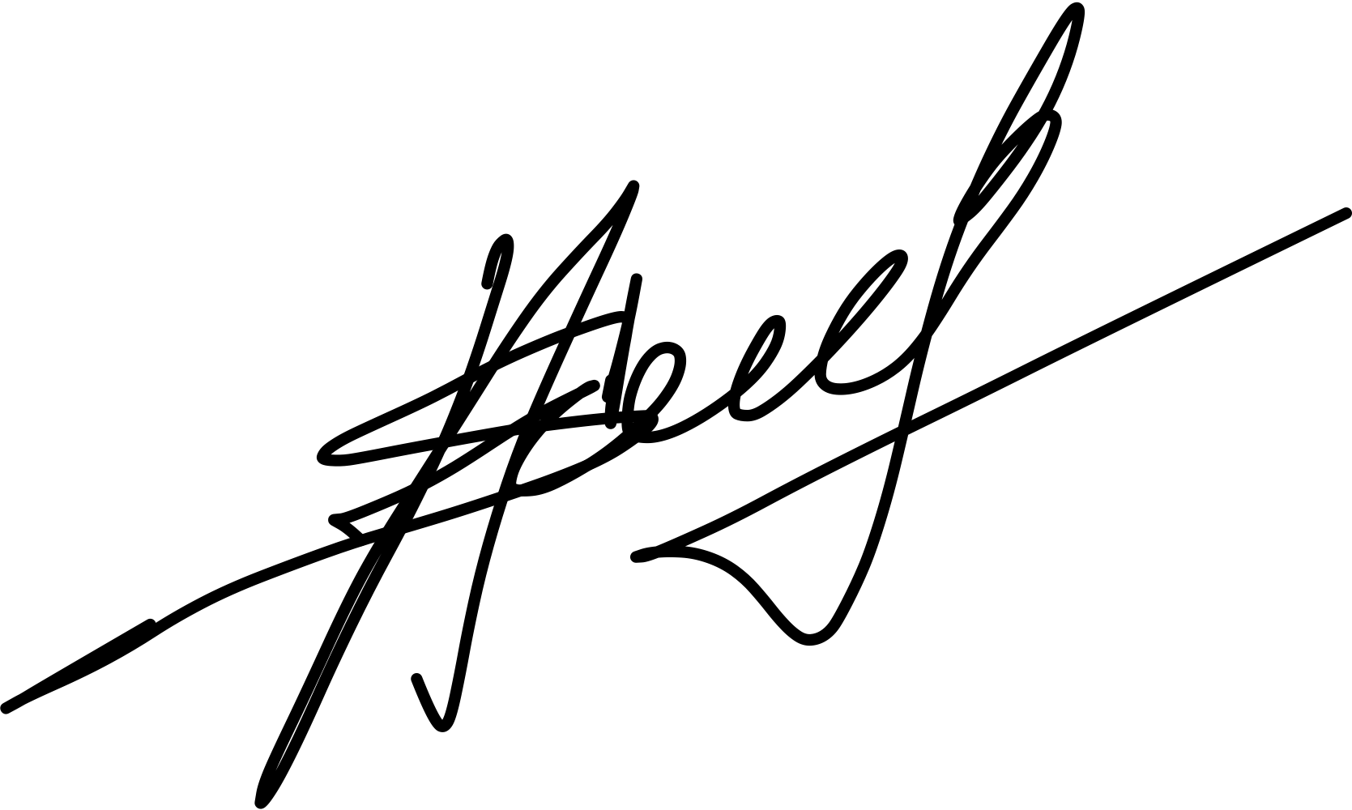
Date: October 8, 2026

Signature:

